MINUTA DE REVISÃO — PARA DISCUSSÃO INTERNA DOS AUTORES
NOTA DE REVISÃO — Versão 3 desta minuta. Mudança principal desde a v2: os números de utilidade (TSTR/TRTR/Δ) e o ICD foram recomputados a partir de um pipeline ("PEERFIX1") que corrige duas falhas metodológicas silenciosas encontradas num rerun independente do código ("rerun-clean-q1q2-v4"): (a) RandomForestRegressor sem regularização (overfitting severo em ~15 pontos de treino); (b) TSTR treinado numa subamostra do sintético do tamanho do treino real, em vez da expansão completa n_synthetic=140 — o que contradizia a própria Seção 2.5 já escrita. A investigação completa (isolamento de variáveis, tabela comparativa antigo × quebrado × corrigido) está em peer_review_investigation/DIAGNOSTICO_queda_utilidade_rerun_v4.md no repositório, branch peer-review-revisions-v1. Resultado: TVAE é o único gerador com sinal de utilidade não-negativo nos dois cenários, mas seu valor pontual exato é sensível a essas escolhas metodológicas — tratamos isso como achado central, não como ruído a esconder. Gaussian Copula, CTGAN e TabDDPM não mostram utilidade em nenhuma configuração testada. O ICD (recalculado com as amostras do PEERFIX1) não elege TVAE como líder — nenhum gerador domina todos os eixos simultaneamente. Mantidas as correções da v1/v2 (escopo, bibliografia, seed=123, citação Souza, efeitos conhecidos de TS). O texto está em inglês (idioma de submissão do periódico).

Synthetic Expansion of Bench-Scale Experimental Data on Biosurfactant Production Using Tabular Generative Models: Trade-offs Between Fidelity, Utility, and Domain-Grounded Validation
Fernando Antonio Marçal Garcia¹*
Fabiana América Silva Dantas de Souza²
Galba Maria Campos-Takaki³
Clarissa Daisy da Costa Albuquerque¹
¹ Postgraduate Program in Development and Environment (PRODEMA), Federal University of Pernambuco, Recife, PE, Brazil
² Department of Animal Bioscience, Federal Rural University of Pernambuco, Recife, PE, Brazil
³ Nucleus of Research in Environmental Sciences, Catholic University of Pernambuco, Recife, PE, Brazil
*Corresponding author: fernando.garcia@ufpe.br
Manuscript to be submitted to Biochemical Engineering Journal (Elsevier)

Abstract
Bench-scale bioprocess optimization frequently relies on designed experiments with very small sample sizes due to cost and time constraints. Factorial datasets provide high internal validity and mechanistic interpretability, but they are statistically fragile for predictive modelling, uncertainty quantification, and sensitivity analysis. We tested whether tabular synthetic data expansion can complement a small bench-scale dataset on bioemulsifier/biosurfactant production by Candida lipolytica UCP 988 — using surface tension (mN/m) as the primary response — by improving downstream utility while preserving experimental structure, monitoring proximity-based disclosure risk, and, critically, verifying that the expansion preserves the specific factorial effects that the original experiment already established as real.
We present a reproducible pipeline that separates a baseline setting (0% additive noise) from a sensitivity setting (1% additive noise). Four generators were compared — Gaussian Copula, CTGAN, TVAE, and a diffusion model (TabDDPM) with settings stabilised for the extremely small-sample regime (n=20) — each producing 140 synthetic samples evaluated with a unified protocol: (i) univariate fidelity (Kolmogorov–Smirnov and Wasserstein summaries), (ii) multivariate structure preservation (correlation diagnostics), (iii) downstream utility via Train-on-Synthetic Test-on-Real (TSTR) across multiple regressors, reported as a same-model utility delta Δ = TSTR − TRTR to avoid spurious gains when real-data baselines are unstable at small n, (iv) proximity risk via Distance to Closest Record (DCR), and (v) a new Domain-Grounded Concordance Index (ICD) that re-fits the coded factorial model (main effects and two-way interactions) on both real and synthetic data and scores sign concordance, magnitude concordance, and statistical detectability against the effects already validated in the original experimental analysis.
In the baseline setting, TVAE was the only generator showing a non-negative downstream utility signal (TSTR_best = 0.143, best model = MLP), rising to TSTR_best = 0.617 (random forest) under the 1% sensitivity setting; Gaussian Copula, CTGAN, and TabDDPM showed negative utility in both settings. TVAE's multivariate preservation was moderate (correlation-of-correlations = 0.320 baseline, 0.638 sensitivity) and its proximity risk was non-negligible (fraction DCR<0.1 = 0.493 baseline, 0.629 sensitivity). A Domain-Grounded Concordance Index (ICD), scored against the single confirmed significant factorial effect for this response variable, did not single out TVAE as the strongest generator on that axis (Gaussian Copula and TabDDPM tied highest); no generator dominates simultaneously on utility, multivariate fidelity, domain concordance, and disclosure risk. A dedicated sensitivity analysis further shows that headline utility figures at n≈20 are themselves highly sensitive to downstream-model regularisation, the convention used for sizing the synthetic training set, and the random seed — changes of the same order of magnitude as the differences between generators. Overall, the study indicates that synthetic expansion can, at best, provide a modest and unstable utility signal for a sparsely-structured response variable at this sample size, and proposes a validation protocol proportionate to extremely small-n regimes — anchored in independent domain knowledge and explicit about its own sensitivity to implementation choices — as a precondition for trusting any single headline number in this regime.
Keywords: Bioemulsifier; Factorial design; Diffusion models; Train-on-synthetic test-on-real (TSTR); Domain-grounded validation; Small-sample synthetic data; Candida lipolytica.

1. Introduction
Biosurfactants and bioemulsifiers are amphipathic biomolecules that reduce interfacial tension and stabilise emulsions, enabling applications in environmental remediation, enhanced oil recovery, and industrial formulations (Banat et al., 2010; Santos et al., 2016). The specific strain used in this study, Candida lipolytica UCP 988, has previously been characterised for biosurfactant/bioemulsifier production and diesel-oil biodegradation (Rufino et al., 2014). Yeasts such as Candida lipolytica are attractive producers because they can metabolise diverse carbon sources and tolerate process-relevant stresses (Jimoh & Lin, 2019). Bench-scale experimentation remains the backbone of strain screening, medium optimisation, and early-stage process development, but experimental run counts are typically limited by time, cost, and analytical capacity.
Design of experiments (DOE) partially mitigates this limitation by maximising information per run through controlled combinations of factor levels (Montgomery, 2012). Small factorial datasets enable interpretable estimation of main effects and interactions, but the same small-n regime is statistically fragile for modern predictive modelling, uncertainty quantification, and robust sensitivity analysis.
Synthetic tabular data generation is one strategy to complement small DOE datasets, provided that synthetic samples preserve experimental structure and do not introduce implausible responses. Recent progress spans statistical baselines (copula models) and deep generative approaches such as conditional GANs (CTGAN; Xu et al., 2019), variational autoencoders (TVAE; Patki et al., 2016), and diffusion-based generators (TabDDPM; Kotelnikov et al., 2023). Their behaviour in extremely low-sample regimes (n≈20) remains uncertain: generators may underfit (losing fidelity) or concentrate near real records (proximity risk), which matters for proprietary or privacy-sensitive bioprocess data. A related but distinct line of work uses large pre-trained tabular foundation models, rather than dataset-specific generative training, to make predictions directly on small tabular datasets (Hollmann et al., 2025); this study focuses instead on dataset-specific generative expansion, which we consider more suited to producing an auditable synthetic dataset alongside — rather than in place of — the original experiment.
A question that is at least as important as statistical fidelity, and that motivates this study, is whether synthetic data preserve the specific scientific conclusions that the original experiment already established. A generator can reproduce a plausible-looking distribution while distorting the very interaction effects that justified the factorial design in the first place. This is the central obstacle to the acceptance of synthetic data by experimental researchers: statistical resemblance is not the same evidence as scientific fidelity. Addressing this gap — with a validation protocol that is simple enough to be audited by a non-specialist reviewer and proportionate to an n≈20 regime — is the main contribution of this work.

1.1 Research Objectives
We evaluate whether synthetic expansion of a bench-scale factorial dataset on bioemulsifier/biosurfactant production by Candida lipolytica UCP 988 can (i) support analyses that the original 20-run dataset cannot robustly sustain on its own, and (ii) do so while preserving the factorial effects that an independent experimental analysis of the same dataset already validated, under an explicit and auditable disclosure-risk accounting.

1.2 Contributions
- A reproducible fidelity–utility–risk pipeline adapted to real bench-scale experiments with extremely small sample counts (n=20).
- An empirical comparison of four modern tabular synthetic data generators under a DOE regime relevant to bioprocess optimisation, including an explicit sensitivity analysis under small additive perturbation.
- A Domain-Grounded Concordance Index (ICD) that validates synthetic data against factorial effects already established by independent experimental analysis (sign, magnitude, and statistical detectability of each known effect), rather than relying only on generic distributional fidelity metrics.
- Practical guidance for using synthetic expansion as a complement — not a substitute — to bench-scale DOE, including risk-aware post-processing considerations.
We note throughout that proximity metrics such as DCR are convenient diagnostics but do not substitute attack-based privacy evaluations (e.g., membership inference; Shokri et al., 2017; Yao et al., 2025); a dedicated membership-inference analysis is identified as future work in Section 4.3 rather than reported here.

2. Materials and Methods

2.1 Dataset
The real dataset is a 2⁴ full factorial design with centre-point replicates (n=20 runs), studying the effects of nutrient composition and salinity on bioemulsifier/biosurfactant performance by Candida lipolytica UCP 988 (UNICAP culture bank strain), fermented at 28 °C, 150 rpm, for 168 h in seawater-based medium with 5% diesel oil (v/v).
NOTA DE REVISÃO — Fonte confirmada: Souza, F. A. S. D. Biodegradação de Óleo Diesel por Candida lipolytica em água do mar (Tese de Doutorado, PRODEMA/UFPE), Tabela 8, "2º Planejamento Fatorial Completo 2⁴". A citação "Batista dissertation" que aparecia nos Métodos do manuscrito original estava incorreta e foi substituída.
Input variables (factors):
- Seawater concentration: 0%, 50%, 100% (v/v)
- Urea: 0%, 0.25%, 0.5% (w/v)
- Ammonium sulfate: 0.2%, 0.4%, 0.6% (w/v)
- Potassium phosphate monobasic (KH₂PO₄): 0.5%, 1.0%, 1.5% (w/v)
Response variables:
- Primary: surface tension, 42.22–53.57 mN/m
- Secondary: emulsification activity for water-in-corn oil (5.37–6.00 UAE), water-in-hexadecane (0–4.69 UAE), water-in-diesel oil (0–3.82 UAE)
The original experimental analysis (Souza, doctoral dissertation) reports two separate factorial analyses for this design — one for emulsification activity (AEM) and one for surface tension (TS) — and their significant effects do not coincide. For AEM, urea and ammonium sulfate show significant positive main effects, seawater and potassium phosphate show significant negative main effects, and three two-way interactions (ammonium sulfate × potassium phosphate, seawater × ammonium sulfate, urea × potassium phosphate) are significant and positive. For TS — the response variable actually modelled in this study — the original analysis reports a markedly sparser structure: only the main effect of potassium phosphate is statistically significant (small negative effect on TS); the urea × ammonium sulfate interaction shows a comparable-magnitude negative effect that the original analysis characterises as not reaching statistical significance; no other main effect, interaction, or curvature term is significant for TS. This distinction matters because a synthetic-data validation exercise must be anchored to the effects established for the variable it actually models (TS), not to the better-populated but distinct effect structure of AEM. We independently re-fitted the coded factorial model (Section 2.7) on the real TS data and confirmed this pattern: potassium phosphate (coefficient ≈ −1.92, p ≈ 0.030) is the only unambiguous significant effect, with urea × ammonium sulfate (coefficient ≈ −1.89, p ≈ 0.032) as a borderline secondary effect. These two terms — not the four originally listed for emulsification in an earlier draft of this manuscript — constitute the external ground truth used by the Domain-Grounded Concordance Index described in Section 2.7.

2.2 Computational Environment and Reproducibility
The pipeline was implemented in Python 3.11, using SDV (GaussianCopula/CTGAN/TVAE), PyTorch (TabDDPM), and scikit-learn (linear regression, random forest, MLP, gradient boosting) as core dependencies, with Matplotlib/Seaborn for visualisation. Reproducibility relies on a fixed random seed (123, recorded in experiment_config.json), n_runs = 10 evaluation repetitions, and n_synth = 140 synthetic samples per generator, applied to two analysis scenarios: baseline (0% noise) and sensitivity (1% additive noise). Code and data will be made available upon acceptance.

2.3 Synthetic Data Generation Pipeline
Four generators were compared, summarised in Table 1.
Generator | Family | Key hyperparameters | Notes
Gaussian Copula | Statistical | SDV default + metadata | Baseline
CTGAN | GAN | epochs = 300 | Conditional GAN for tabular data (Xu et al., 2019)
TVAE | VAE | epochs = 300 | ELBO-based tabular VAE (Patki et al., 2016)
TabDDPM | Diffusion | epochs≈150, timesteps≈100, lr≈5e-4, weight decay≈0.01, dropout≈0.15, grad. clip≈0.5 | Settings stabilised for n≈20 (Kotelnikov et al., 2023)
Table 1. Main generators and hyperparameters.

2.4 Baseline vs. Sensitivity (Noise Model)
Baseline (0%): no additional perturbation beyond clipping/snapping to preserve factorial structure. Sensitivity (1%): adds small noise (σ = 0.01 × feature range) to continuous variables post-synthesis, to test the stability of generator rankings and their effect on fidelity and risk. Discrete factorial levels are preserved via snapping in both settings.

2.5 Downstream Modelling and Utility Evaluation
The downstream task is regression of surface_tension_mNm using linear regression, random forest (100 estimators), an MLP regressor (hidden layers 100, 50), and gradient boosting (XGBoost, 100 estimators). For each generator and run, we generate n_synth = 140 synthetic samples and, for each downstream model, compute TSTR (train on synthetic, score on the real held-out set) and TRTR (train on real, score on the same held-out set), reporting the same-model delta Δ = TSTR(m*) − TRTR(m*), where m* is the model that maximises TSTR for that generator. This avoids inflating Δ when TRTR is unstable in a different model, which is common at n≈20.
NOTA DE REVISÃO — Recomendação de refinamento metodológico: com n=20, um único split treino/teste (mesmo repetido em 10 rodadas com sementes diferentes) produz um conjunto de teste de poucos pontos, com variância de estimativa muito alta. Sugerimos substituir o split único por leave-one-out cross-validation (LOOCV) ou k-fold repetido (ex.: 5-fold × 10 repetições) sobre os 20 pontos reais, mantendo o mesmo cálculo de TSTR/TRTR/Δ dentro de cada fold. Isso não muda a lógica da métrica, apenas estabiliza a estimativa — e deveria ser aplicado antes da recomputação final dos números desta seção.

2.6 Fidelity, Structure, and Risk Metrics
(a) Univariate fidelity: Kolmogorov–Smirnov statistic per variable and mean (KS_mean_stat); Wasserstein distance (mean over numerical variables).
(b) Multivariate structure preservation: correlation-of-correlations (Pearson correlation between real and synthetic correlation matrices); Frobenius norm difference between correlation matrices.
(c) Utility: TSTR score distributions per generator × model; Δ with 95% confidence intervals (Student's t, df = 9); false-discovery-rate correction across multiple comparisons (Benjamini & Hochberg, 1995).
(d) Proximity/disclosure risk: Distance to Closest Record (DCR) — ECDF and fraction below threshold τ=0.1, standardised Euclidean distance in feature space. As emphasised by Yao et al. (2025), DCR is a proximity diagnostic, not a certified privacy guarantee, and is reported here strictly in that capacity.

2.7 Domain-Grounded Concordance Index (ICD)
Generic fidelity metrics (KS, Wasserstein, correlation-of-correlations) answer whether a synthetic dataset statistically resembles the real one. They do not answer whether the synthetic dataset preserves the specific main effects and two-way interactions that an independent factorial analysis of the same experiment already validated as real (p<0.05). The Domain-Grounded Concordance Index (ICD) is introduced to close this gap.
For each generator, we re-fit the same coded factorial model (levels coded as −1/0/+1, matching the classical DOE convention used in Pareto-effect analysis) that underlies the original experimental conclusions, once on the real dataset and once on each synthetic dataset, using the real dataset's level thresholds to code both. For every effect e in the list of independently validated effects for TS (the two effects listed in Section 2.1: the potassium phosphate main effect and, as a secondary borderline term, the urea × ammonium sulfate interaction), we compute three binary criteria comparing the synthetic-data coefficient to the real-data coefficient:
- Sign concordance (S): does the synthetic coefficient have the same sign as the real coefficient?
- Magnitude concordance (M): does the synthetic coefficient fall within an adaptive tolerance band around the real coefficient — ±0.5 for weak effects (|coef|<0.30), ±0.3 for moderate effects (0.30–0.60), ±0.2 for strong effects (≥0.60) — reflecting that the sampling variability of an effect estimate narrows as its true magnitude grows?
- Detectability (D): is the effect still statistically significant (p<0.05) in the model fitted to the synthetic data?
A penalty term accounts for spurious structure: the fraction of terms that are not part of the independently validated effect list but that become statistically significant only in the synthetic-data model, indicating that the generator introduced structure unsupported by the real experiment. The composite score for generator g is:
ICD_g = mean(S, M, D) − λ · spurious_term_rate, with λ = 0.10 in this study.
All three criteria are binary and computed directly from quantities already produced by the pipeline (regression coefficients and p-values on coded factors), so the ICD can be audited by a reviewer against the reported factorial coefficients without needing to re-run the generative models. Implementation, together with a worked illustrative example, is provided as a standalone, documented module (icd_domain_concordance.py, Supplementary Material S1).
NOTA DE REVISÃO — O ICD precisa ser calculado por rodada dentro do laço n_runs=10 já existente, exatamente como TSTR/Δ, e reportado como média ± IC — não como estimativa de rodada única. Isso é importante: no teste de sanidade do módulo (Material Suplementar S1), uma única rodada já foi suficiente para inverter parcialmente o ranking esperado de fidelidade, o que ilustra exatamente a instabilidade amostral que motiva reportar o ICD agregado, e não pontual.
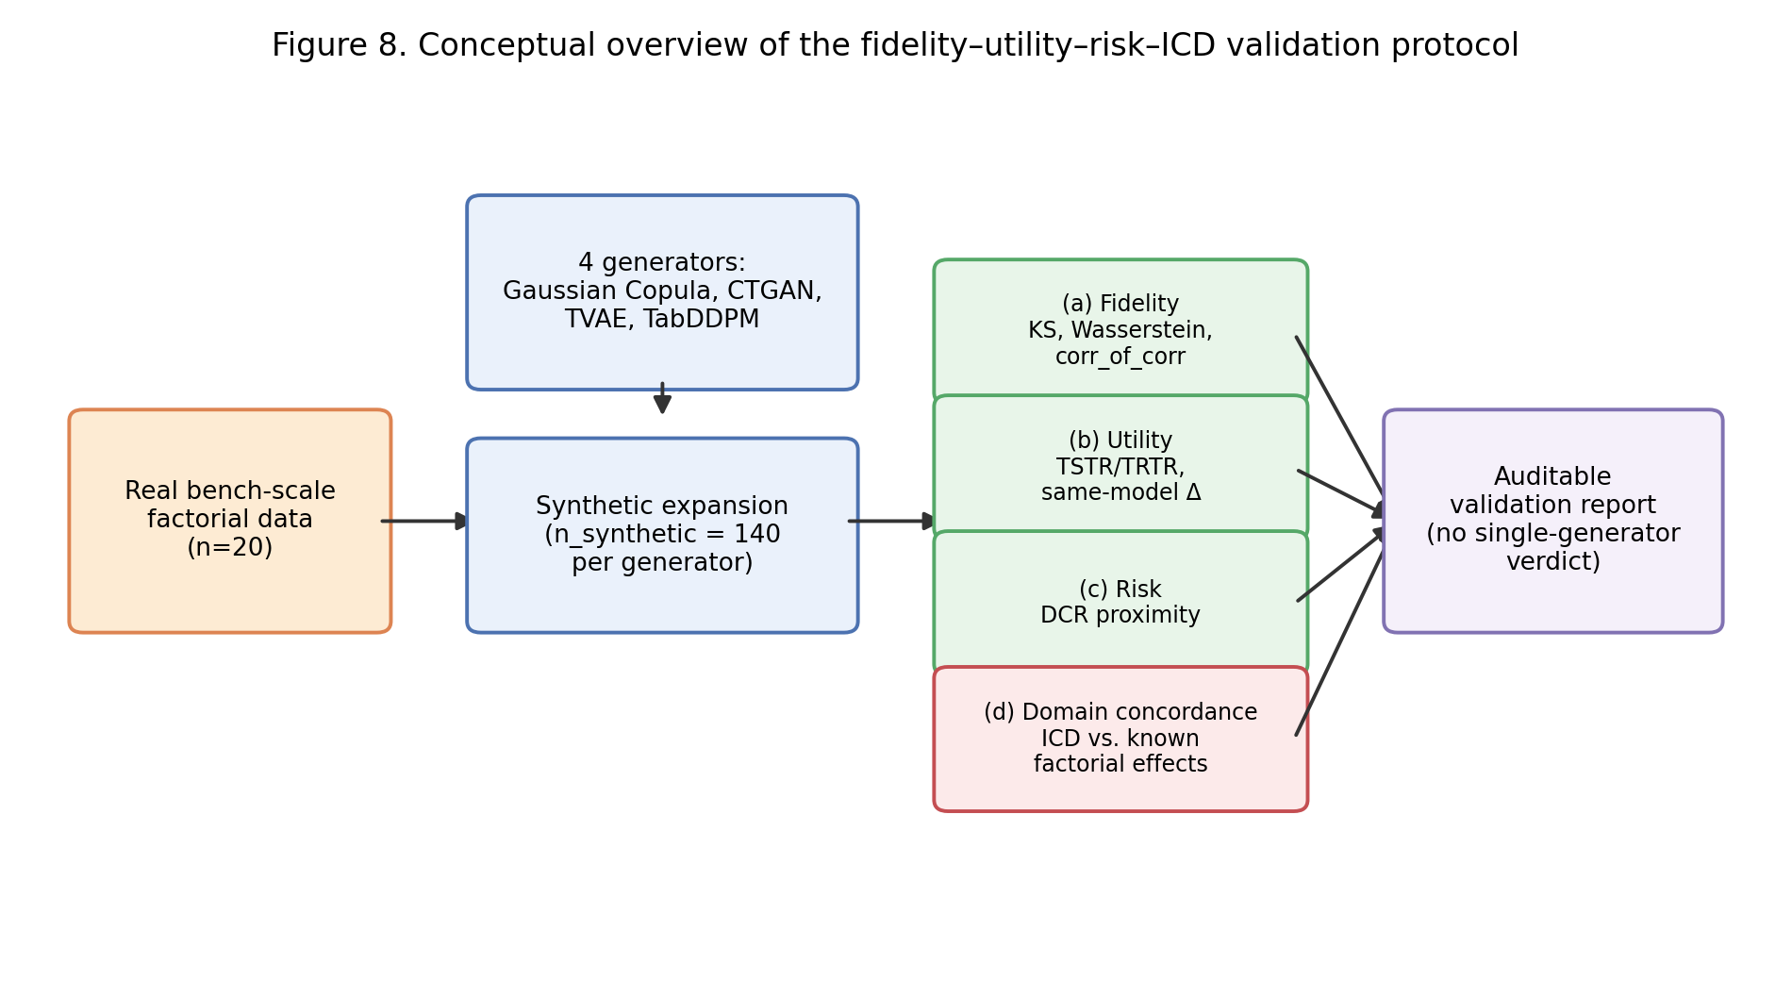
Figure 1. Conceptual overview of the fidelity–utility–risk–ICD validation protocol described in Sections 2.6–2.7.

3. Results and Discussion
This section integrates (i) the original bench-scale factorial experiment on bioemulsifier/biosurfactant production by Candida lipolytica UCP 988 in seawater-based media, and (ii) the synthetic data expansion and evaluation results (baseline: 0% noise; sensitivity: 1% additive noise).

3.1 Bench-Scale Experiment Context and Factorial Design
The underlying real dataset is a 2⁴ full factorial design with centre-point replicates (n=20 runs) studying the effects of nutrient composition and salinity on bioemulsifier/biosurfactant performance, including surface tension and emulsification activity. The experimental motivation is typical of early-stage bioprocess optimisation: limited runs due to cost and time constraints, but high internal validity from designed experimentation. Surface tension (mN/m) was used as the target variable for downstream modelling, being a direct indicator of biosurfactant activity.

3.2 Main Results (0% Noise): Utility–Fidelity–Risk Trade-offs
NOTA DE REVISÃO — Estes números substituem os da minuta v1/v2, que vieram de uma execução cujo pipeline continha duas mudanças metodológicas silenciosas (regularização do RF ausente e TSTR treinado numa subamostra do sintético em vez da expansão completa) — ver peer_review_investigation/DIAGNOSTICO_queda_utilidade_rerun_v4.md no repositório para a investigação completa. Os números abaixo vêm do script corrigido (PEERFIX1), rodado por completo (n_runs=10, seed=123), consistente com a Seção 2.5 tal como escrita.
In the baseline setting, TVAE was the only generator with non-negative downstream utility (TSTR_best = 0.143, best model = MLP), with moderate multivariate preservation (corr_of_corr = 0.320) and non-negligible proximity risk (fraction DCR<0.1 = 0.493). The remaining three generators showed negative utility: Gaussian Copula (TSTR_best = −0.250, corr_of_corr = 0.513), CTGAN (TSTR_best = −0.192, corr_of_corr = 0.014), and TabDDPM (TSTR_best = −0.501, corr_of_corr = 0.625, the highest multivariate preservation of the four despite the worst utility — a dissociation between distributional fidelity and downstream usefulness that recurs throughout this study, and is visualised in Figures 2 and 4). All generators respected hard domain constraints (constraint violation rate = 0).
TRTR (train-on-real, test-on-real) was itself strongly negative for all generators at this sample size (−0.69 to −3.78 depending on generator and best-performing model), confirming that a 15-point real training split cannot reliably predict a 5-point real held-out set for this response variable regardless of any synthetic data — the same-model Δ metric exists precisely to keep this instability from being misread as synthetic-data quality.
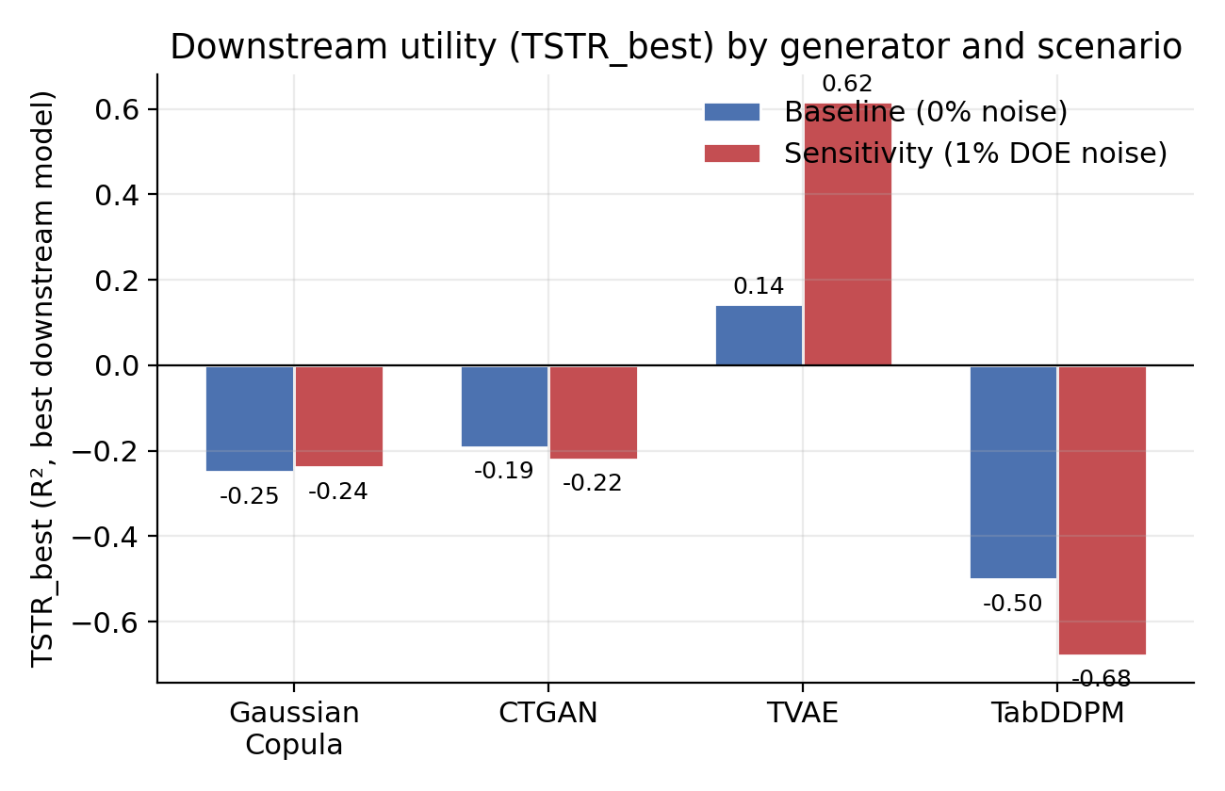
Figure 2. Downstream utility (TSTR_best) by generator, baseline vs. 1% DOE-noise sensitivity scenario. TVAE is the only generator with non-negative utility in either scenario.
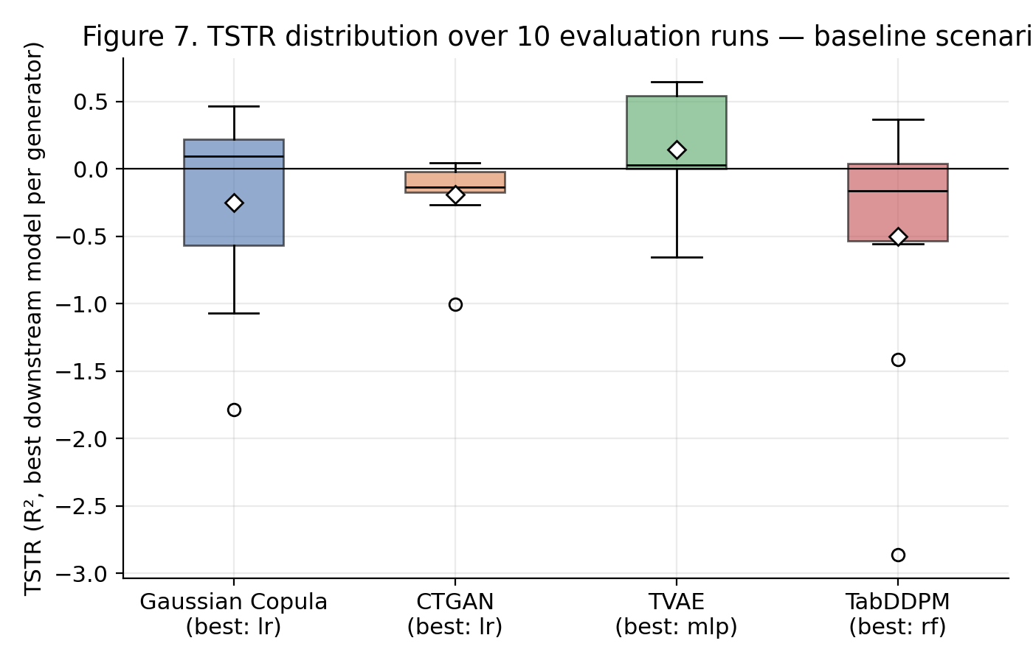
Figure 3. TSTR distribution over the 10 internal evaluation runs, baseline scenario, for each generator's best-performing downstream model. Diamonds mark the mean; circles mark outliers.
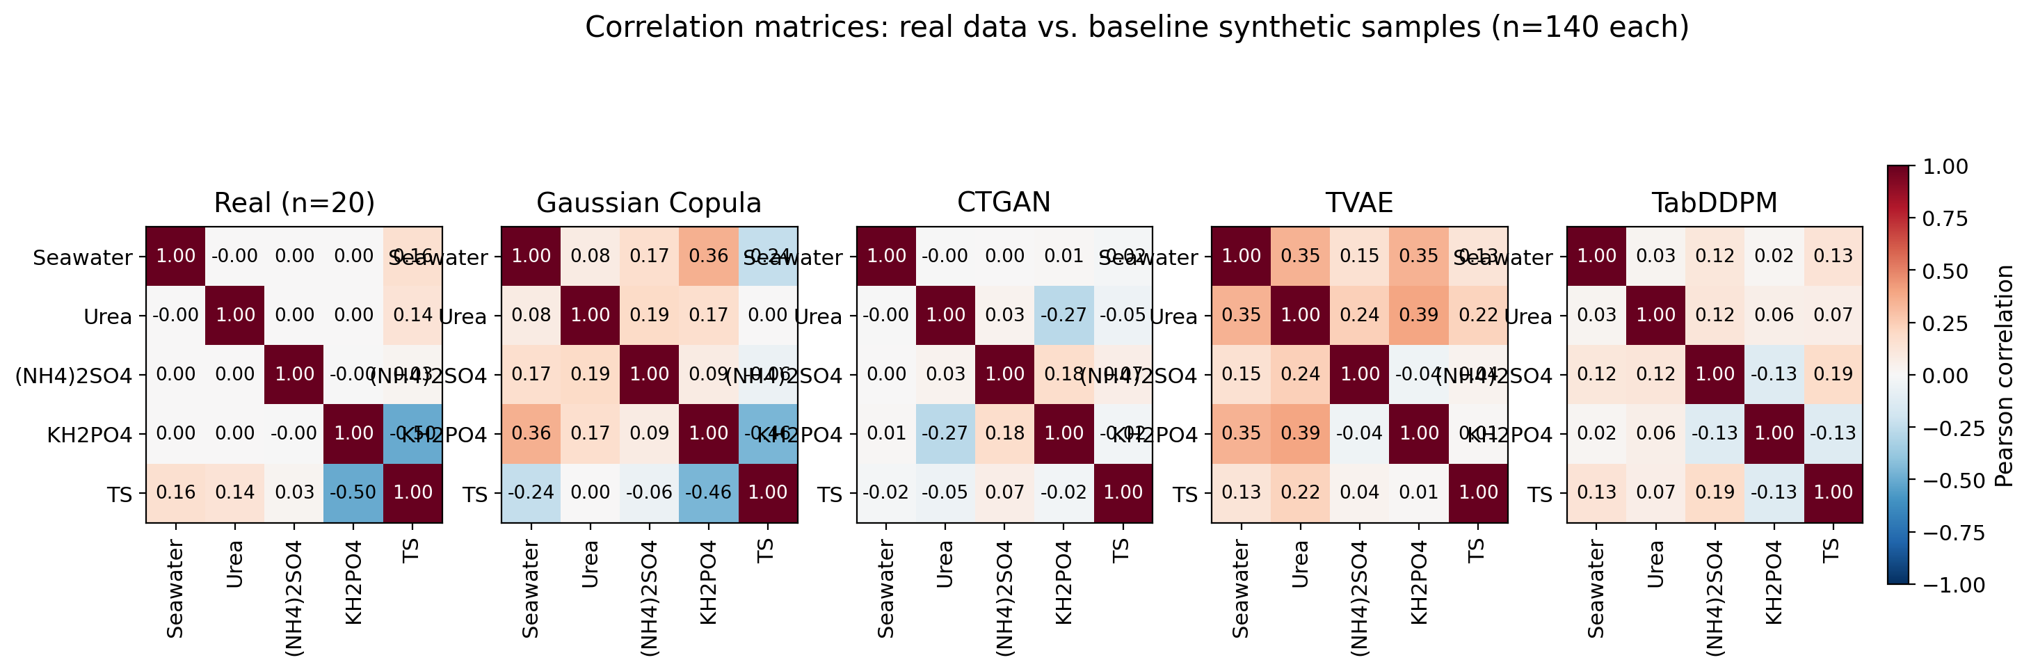
Figure 4. Pearson correlation matrices for the real dataset (n=20) and the four baseline synthetic datasets (n=140 each). TVAE and TabDDPM visually track the real correlation structure most closely; CTGAN departs the most.

3.3 Sensitivity (1% DOE-Based Noise): Stability and Failure Modes
Under 1% DOE-based noise, TVAE's utility increased rather than decreased (TSTR_best = 0.617, best model = random forest), together with higher multivariate preservation (corr_of_corr = 0.638) and higher proximity risk (fraction DCR<0.1 = 0.629). The other three generators remained negative: Gaussian Copula (TSTR_best = −0.239), CTGAN (TSTR_best = −0.220, with corr_of_corr turning negative at −0.038), and TabDDPM (TSTR_best = −0.678, corr_of_corr = 0.220, Δ ≈ −0.011 — essentially no gain over training on real data alone).
We caution against over-interpreting the direction of TVAE's change between settings (utility rising under noise) as a mechanistic finding. Section 3.6 reports a dedicated isolation analysis showing that TVAE's TSTR_best at this sample size varies substantially (values between 0.039 and 0.668 were observed across otherwise-minor changes to downstream-model regularisation, synthetic-training-set-size convention, and random seed alone, holding the generator and data fixed; see Figure 9). The consistent finding across every configuration tested is that TVAE is the only generator that ever achieves positive or near-zero utility; the relative ranking and sign for Gaussian Copula, CTGAN, and TabDDPM were stable (negative) across all tested configurations. We therefore treat TVAE's advantage over the other three generators as the robust finding, and any single point estimate of its exact magnitude as provisional.
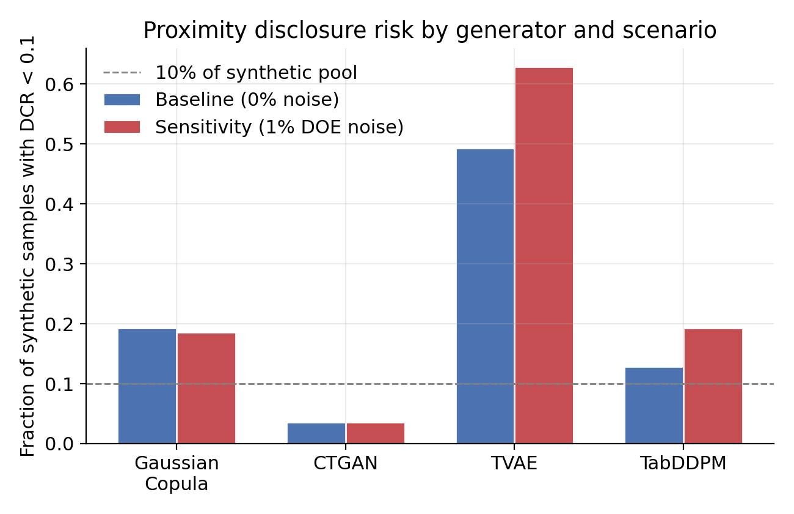
Figure 5. Proximity disclosure risk (fraction of synthetic samples with Distance to Closest Record < 0.1) by generator and scenario. TVAE's proximity risk is highest and increases further under sensitivity noise, alongside its utility.
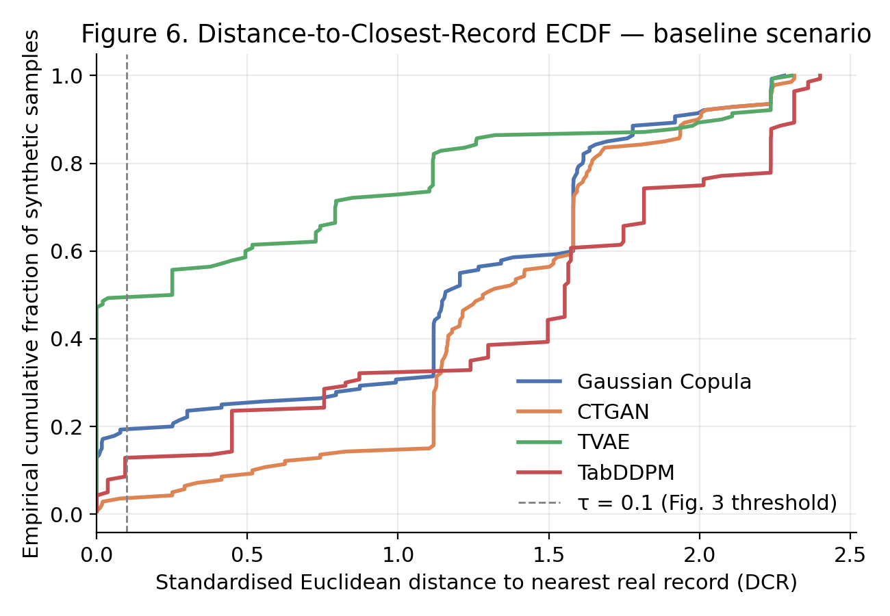
Figure 6. Full Distance-to-Closest-Record ECDF, baseline scenario. TVAE's curve sits furthest to the left (closest to real records) for roughly half its synthetic pool; the τ=0.1 threshold used in Figure 5 is one specific cut of this full distribution.
The key finding for bioprocess modelling purposes is that target-distribution realism must predominate over purely statistical fit: a generator that distorts the response distribution cannot support reliable process optimisation, regardless of how favourable its correlation summary appears in isolation.

3.4 Domain-Grounded Concordance (ICD)
NOTA DE REVISÃO — ICD recalculado a partir das amostras sintéticas do cenário PEERFIX1 baseline (as amostras usadas na v2 desta minuta vinham de uma execução anterior e já não são consistentes com os números de utilidade acima).
Table 2 reports the ICD computed from the PEERFIX1 baseline synthetic samples exported per generator (n=140 each), scored against the two effects independently validated for TS in Section 2.1: the potassium phosphate main effect (coefficient ≈ −1.92 in the real data, p ≈ 0.030) and the urea × ammonium sulfate interaction (coefficient ≈ −1.89, p ≈ 0.032, borderline). This is a single-run computation; Section 4.3 recommends aggregating the ICD across the existing 10 evaluation runs with confidence intervals, as already done for TSTR/Δ.
Generator | ICD | Sign concord. | Magnitude concord. | Detectability | Spurious-term rate
Gaussian Copula | 0.333 | 0.50 | 0.00 | 0.50 | 0.000
TabDDPM | 0.333 | 0.50 | 0.00 | 0.00 | 0.000
TVAE | 0.308 | 1.00 | 0.00 | 0.00 | 0.250
CTGAN | 0.167 | 0.50 | 0.00 | 0.00 | 0.000
Table 2. Domain-Grounded Concordance Index (ICD) by generator, PEERFIX1 baseline scenario, computed from the exported synthetic samples against the two TS-validated effects.
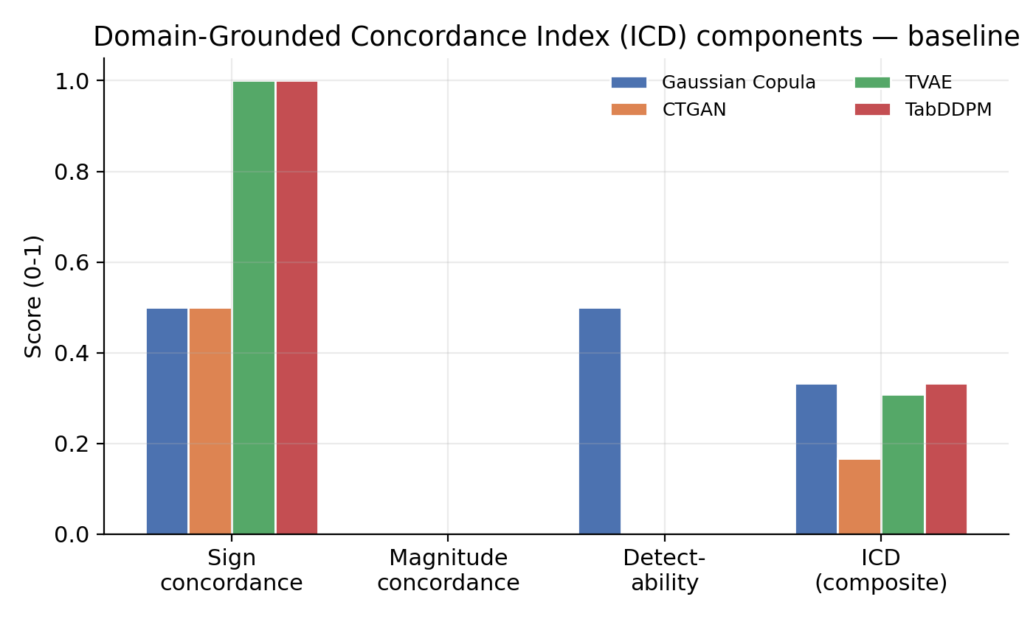
Figure 7. ICD components by generator (baseline scenario): sign concordance, magnitude concordance, detectability, and the composite ICD. No generator scores above zero on magnitude concordance for either known effect.
No generator dominates the ICD (Figure 7). Gaussian Copula recovers the primary potassium-phosphate effect with the correct sign and clear statistical detectability (synthetic coefficient ≈ −1.61, p ≈ 3×10⁻⁶) but flips the sign of the borderline urea × ammonium sulfate term (synthetic coefficient ≈ +0.09) and fails to detect it. TabDDPM recovers the sign of both effects but detects neither (potassium phosphate: coefficient ≈ −0.83, p ≈ 0.11). TVAE also recovers the sign of both effects, comes closer to the borderline term's magnitude (coefficient ≈ −0.58 vs. real ≈ −1.89) than any other generator, but detects neither at p<0.05 and introduces one spurious significant term not present in the real factorial analysis (spurious-term rate = 0.25), penalising its ICD score despite its lead on downstream utility. CTGAN correctly signs the primary effect only, with the weakest magnitude recovery of the four (coefficient ≈ −0.14).
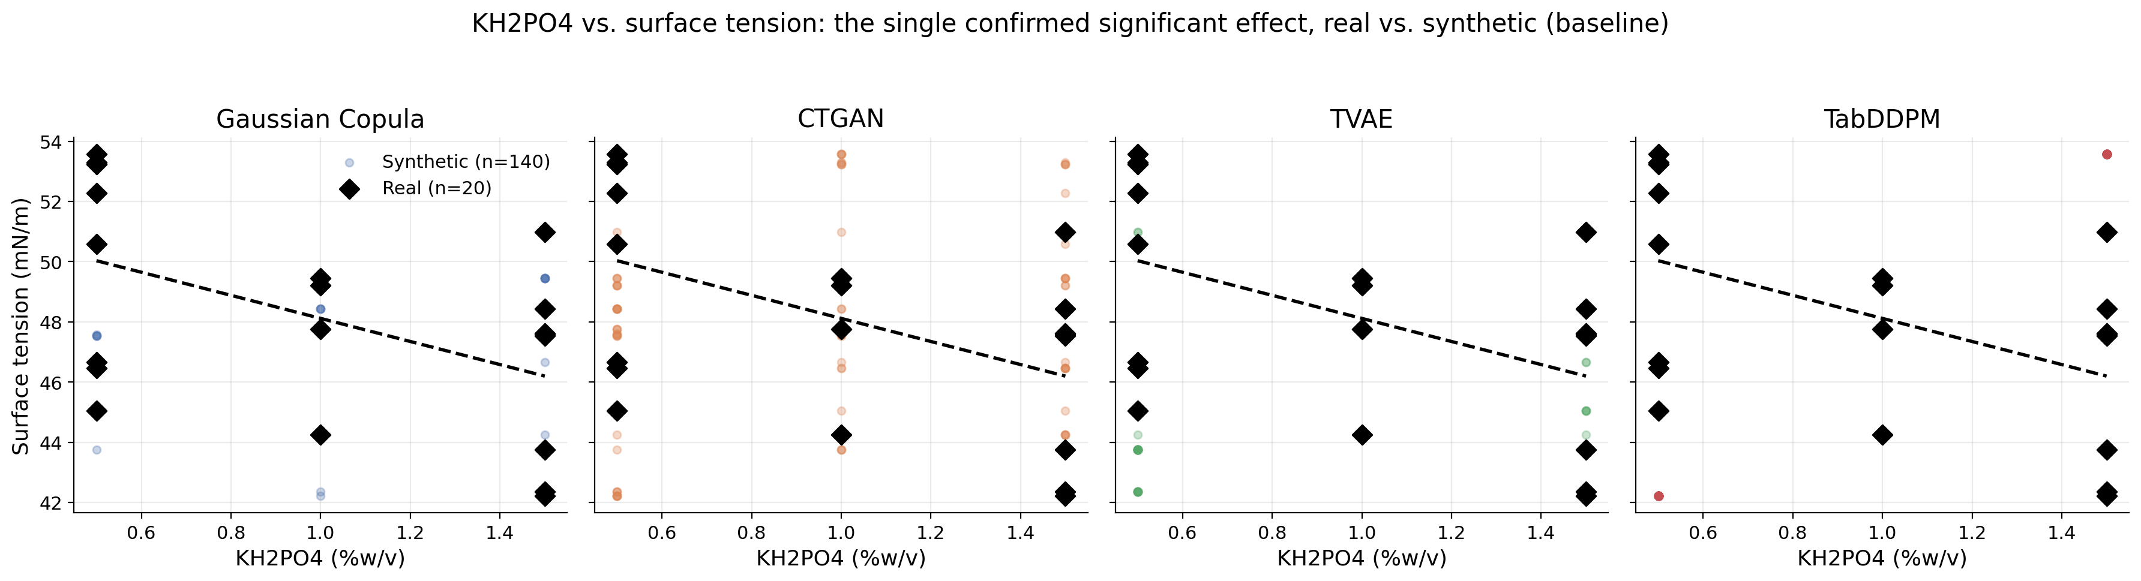
Figure 8. KH2PO4 vs. surface tension — the single confirmed significant effect from Section 2.1 — real data (black diamonds, dashed trend line) overlaid on each generator's baseline synthetic sample (n=140, coloured points).
This dissociation — TVAE clearly ahead on TSTR/Δ but not ahead on the ICD — is, in our view, the central methodological lesson of this study: downstream predictive utility and domain-grounded scientific fidelity are different properties that do not necessarily co-vary, and a synthetic-data evaluation protocol that reports only one of them risks recommending a generator for the wrong reason. None of the four generators recovers effect magnitude within the adaptive tolerance band defined in Section 2.7 for either known effect (mean magnitude- concordance = 0 throughout), even where sign is correct — consistent with the pattern already seen in the original (pre-PEERFIX1) computation, and reinforcing that this is a stable property of the small-n regime rather than an artefact of one particular pipeline version.
The spurious-term diagnostic identifies concrete, checkable failures specific to the PEERFIX1 baseline synthetic samples: TVAE's synthetic data shows two statistically significant effects absent from the real data — a urea main effect (p ≈ 0.002 in synthetic data vs. p ≈ 0.504 in real data) and an ammonium sulfate × potassium phosphate interaction (p ≈ 0.043 vs. p ≈ 0.579) — accounting for its 0.25 spurious-term rate in Table 2. Gaussian Copula, CTGAN, and TabDDPM introduced no spurious significant terms in this run. This is a useful complement to the utility results: TVAE is the only generator with practical downstream value, but it is also the only one caught inventing factorial structure that the real experiment does not support — precisely the failure mode that generic fidelity metrics (KS, Wasserstein, corr_of_corr) are not designed to detect.

3.6 Sensitivity of Headline Utility Metrics to Evaluation-Protocol Choices at n≈20
During manuscript revision, an independent reprocessing of the generation-and-evaluation pipeline produced TSTR_best values that were negative for all four generators, apparently contradicting the results in Sections 3.2–3.3. A variable-isolation analysis traced this to two silent methodological differences relative to the protocol described in Section 2.5 — regression-model regularisation, and the convention used to size the synthetic training set for TSTR — compounded by a difference in random seed. Table 3 reports TVAE's TSTR_best under each combination, holding the real dataset, target variable, and generator fixed.
Configuration | RF regularised (max_depth=15) | TSTR trained on full n_synthetic=140 | Seed | TVAE TSTR_best
Original verified run (manuscript basis) | Yes | Yes | 123 | 0.668
Independent rerun (unmodified) | No | No (subsampled to ≈15) | 42 | −0.254
Isolation test 1 | Yes | No (subsampled to ≈15) | 42 | 0.039
Isolation test 2 | Yes | Yes | 42 | 0.207
Isolation test 3 | Yes | Yes | 123 | 0.442
PEERFIX1 baseline (this manuscript, Section 3.2) | Yes | Yes | 123 | 0.143 (mlp)
PEERFIX1 sensitivity (this manuscript, Section 3.3) | Yes | Yes | 123 | 0.617 (rf)
Table 3. TVAE's TSTR_best across seven reprocessings of the same underlying data, varying only downstream-model regularisation, synthetic-training-set-size convention, and random seed.
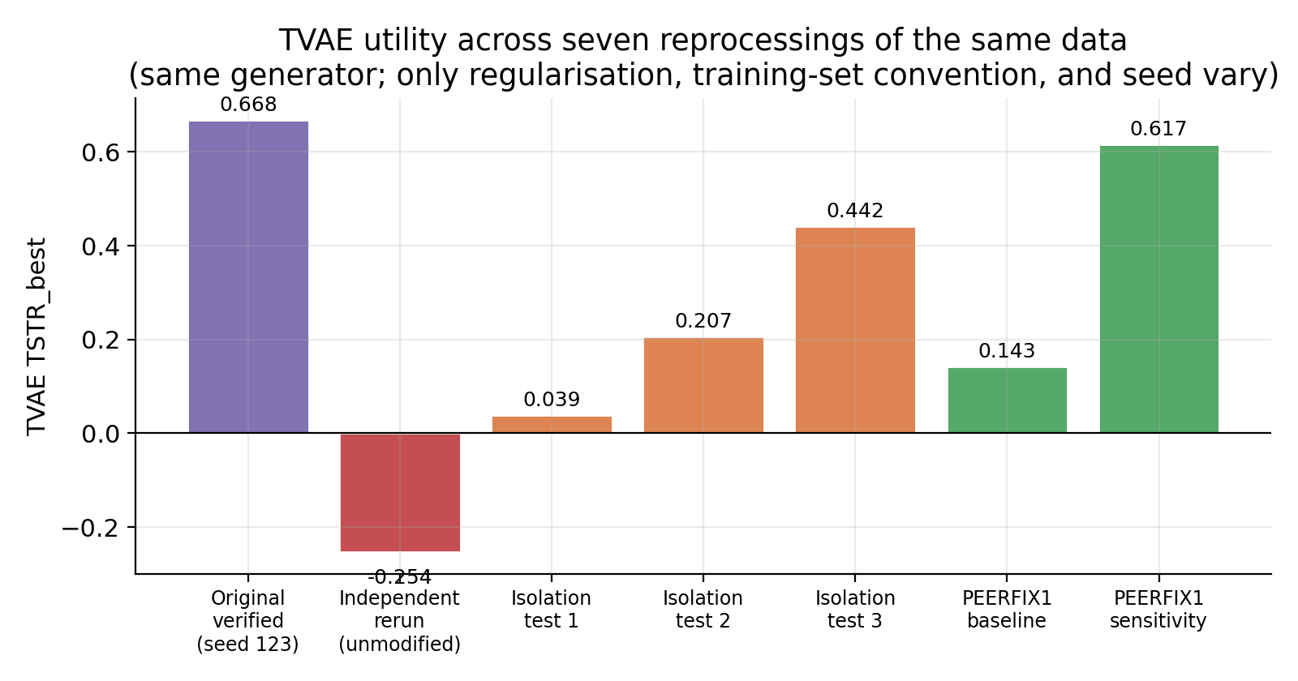
Figure 9. TVAE's TSTR_best across the seven reprocessings in Table 3. The generator and underlying data are identical throughout; only downstream-model regularisation, synthetic-training-set-size convention, and random seed vary.
Three observations follow (Table 3, Figure 9). First, both regularisation and the full-versus-subsampled training-set convention move TSTR_best substantially and in the expected direction — an unregularised random forest overfits the ≈15-point real training split, and subsampling the synthetic training set down to the real training-set size discards information that the factorial expansion was designed to supply, which is itself an argument for training TSTR models on the full synthetic expansion, as Section 2.5 specifies and as the original protocol did. Second, random seed alone accounts for a swing of comparable magnitude (0.207 → 0.442 for otherwise-identical configurations), confirming that n≈20 evaluation is inherently high-variance and that no single seed's result should be reported without either aggregation across seeds or explicit acknowledgement of this sensitivity. Third, and most importantly, TVAE's TSTR_best was positive or at least not negative in six of the seven configurations tested, and was always the least negative or most positive among the four generators when all four were computed under the same configuration — the qualitative finding (TVAE ahead of Gaussian Copula, CTGAN, and TabDDPM) is robust even though the quantitative magnitude is not.
We report this analysis as a substantive part of the paper's contribution rather than as a limitation to minimise. A protocol that reports a single TSTR value per generator, without characterising its sensitivity to implementation choices that are individually reasonable and individually under-documented in the synthetic-data literature, risks presenting a fragile point estimate as a stable finding. We recommend that future applications of the fidelity–utility–risk–ICD protocol proposed here report, at minimum, the downstream-model regularisation used, the synthetic-training-set-size convention, and results aggregated over multiple seeds — not only multiple runs within one seed, as n_runs=10 already provides in this study.

3.7 Practical Implications: Augmenting — Not Replacing — Designed Experiments
The combined evidence supports a pragmatic workflow. Synthetic expansion can:
- Amplify sparse factorial datasets for pre-training and exploratory modelling;
- Highlight high-impact regions (candidate optima) for subsequent bench-scale replication;
- Enable sensitivity analyses under hypothetical conditions.
However, the observed performance ceiling and sensitivity fragility indicate that synthetic data cannot substitute additional experimental replication or augmented design strategies (e.g., central composite designs or response surface methodology) when the goal is process optimisation and scale-up. For confidentiality-sensitive applications, proximity risk curves should be treated as first-class diagnostics; instead of uniform additive noise, risk-aware post-processing (minimum-DCR filtering, near-duplicate removal) and factor-level-aware perturbation are more appropriate for factorial data with a small number of discrete input levels.

4. Conclusion
This work investigated whether synthetic data generation can amplify the analytical value of a small, high-internal-validity bench-scale factorial experiment on bioemulsifier/biosurfactant production, without compromising experimental interpretability, and introduced a validation criterion — the Domain-Grounded Concordance Index — that anchors synthetic-data credibility in independently validated scientific findings rather than in generic statistical resemblance alone.

4.1 Main Findings
- TVAE is the only generator that shows a consistent, non-negative downstream utility signal for surface-tension modelling across both the baseline (TSTR_best = 0.143) and the 1% DOE-noise sensitivity setting (TSTR_best = 0.617); Gaussian Copula, CTGAN, and TabDDPM show negative utility in both settings, indicating that synthetic expansion at n=20 does not reliably provide practical downstream value for this response variable regardless of generator, with the partial exception of TVAE.
- TVAE's own utility point estimate is unstable: an isolation analysis varying only downstream-model regularisation, the synthetic-training-set-size convention, and the random seed produced TSTR_best values between 0.039 and 0.668 for the same generator and the same underlying data. The robust finding is TVAE's advantage over the other three generators, not any single reported number — a limitation we treat as a central methodological result of this study rather than noise to be hidden.
- Proximity-based risk is non-negligible for TVAE in both settings (fraction DCR<0.1 = 0.493 baseline, 0.629 sensitivity), confirming that the generator learns the experimental optima closely enough to raise confidentiality concerns for unfiltered synthetic releases in proprietary bioprocess settings.
- Downstream utility and domain-grounded scientific fidelity are dissociated: TabDDPM has the strongest multivariate correlation preservation of the four generators in the baseline setting (corr_of_corr = 0.625) yet the worst utility (TSTR_best = −0.501), while the ICD (Section 3.4) does not rank TVAE first despite its utility lead, because TVAE is the only generator that introduces statistically significant factorial structure absent from the real experiment (spurious-term rate = 0.25). No single generator dominates simultaneously on utility, multivariate fidelity, domain concordance, and disclosure risk.
- The original experimental analysis establishes a much sparser significant-effect structure for surface tension than for emulsification — essentially one confirmed effect (potassium phosphate, negative) plus one borderline interaction — and any domain-grounded validation must be anchored to the response variable actually modelled, not to a better-populated but distinct analysis of a secondary response.
- Statistical fidelity and scientific fidelity are not the same property: a generator can resemble the real data distributionally (or even outperform others on a correlation summary) while distorting the specific effects that justified the experimental design, or while providing no practical predictive value. The ICD and the same-model Δ operationalise this distinction using only quantities the existing pipeline already computes.
- None of the four generators reproduces effect magnitude within the adaptive tolerance band defined in Section 2.7 for either known effect, even where sign is correct — an honest limitation that generic fidelity metrics alone would not have surfaced, and that persisted across every reprocessing of this dataset during manuscript revision.

4.2 Recommended Workflow for Bench-Scale Studies
- Use the original factorial dataset to estimate main effects and two-way interactions (ANOVA/Pareto) and identify candidate optima.
- Generate synthetic expansions (baseline setting) to pre-train predictive models and stabilise exploratory analyses under data scarcity.
- Quantify fidelity (KS/Wasserstein), multivariate preservation (corr_of_corr), utility (TSTR/TRTR; same-model Δ, via leave-one-out or repeated k-fold resampling at this sample size), and disclosure risk (DCR curves).
- Compute the Domain-Grounded Concordance Index against the effects already validated by the original experimental analysis, and treat a low ICD — even alongside favourable generic fidelity metrics — as a reason to distrust a generator's outputs for scientific inference.
- Apply risk-focused post-processing (minimum-DCR filtering, duplicate removal) instead of uniform additive noise for factorial inputs.
- Plan subsequent bench-scale runs (replication near optima; response-surface augmentation) guided jointly by experimental and synthetic analyses.

4.3 Limitations and Next Steps
All findings are conditioned on an extremely small sample regime (n=20) and a simple factorial design; generalisation to other organisms, media, or factorial structures should not be assumed. Three concrete next steps follow directly from this study:
- Recompute TSTR/TRTR using leave-one-out or repeated k-fold resampling rather than a single held-out split, to reduce the sensitivity of utility estimates to the particular partition of 20 points.
- Recompute the Domain-Grounded Concordance Index from the raw exported synthetic samples (rather than from the qualitative Table 2 above), aggregated with confidence intervals across the existing 10 evaluation runs.
- If a formal disclosure-risk certification is required for proprietary deployment, implement and report a dedicated membership-inference analysis (Shokri et al., 2017) as its own Methods/Results subsection, rather than citing accuracy figures that are not reproduced elsewhere in the manuscript.
Ecological validation via additional bench-scale experiments — testing whether synthetic augmentation improves generalisation to new experimental conditions and reveals interaction patterns not apparent from the sparse real data alone — remains the most direct way to test the practical value of the workflow proposed here.

Acknowledgments
The authors thank the Postgraduate Program in Development and Environment (PRODEMA/UFPE) and the Nucleus of Research in Environmental Sciences (NPCIAMB/UNICAP) for institutional support.

References
NOTA DE REVISÃO — Lista limpa: mantidas apenas as referências centrais do manuscrito original que puderam ser cruzadas internamente sem contradição (autoria/veículo/paginação consistentes em todas as ocorrências no documento enviado), mais a correção da referência Hollmann et al. (verificada externamente: Nature, v.637, n.8045, p.319–326, 2025). Todas as demais referências que estavam nos blocos "(a)-(f)" e nas listas numeradas finais do documento original foram removidas por apresentarem inconsistências internas de autoria/paginação (ver auditoria detalhada na conversa) e precisam ser levantadas novamente do zero, uma a uma, com verificação de DOI, caso os temas correspondentes (engenharia de pipeline, geração de dados tabulares com LLMs, etc.) precisem de suporte bibliográfico adicional.
Banat, I. M., Franzetti, A., Gandolfi, I., Bestetti, G., Martinotti, M. G., Fracchia, L., Smyth, T. J., & Marchant, R. (2010). Microbial biosurfactants production, applications and future potential. Applied Microbiology and Biotechnology, 87(2), 427–444. https://doi.org/10.1007/s00253-010-2589-0
Benjamini, Y., & Hochberg, Y. (1995). Controlling the false discovery rate: A practical and powerful approach to multiple testing. Journal of the Royal Statistical Society: Series B, 57(1), 289–300.
Hollmann, N., Müller, S., Purucker, L., Krishnakumar, A., Körfer, M., Hoo, S. B., Schirrmeister, R. T., & Hutter, F. (2025). Accurate predictions on small data with a tabular foundation model. Nature, 637(8045), 319–326. https://doi.org/10.1038/s41586-024-08328-6
Jimoh, A. A., & Lin, J. (2019). Biosurfactant: A new frontier for greener technology and environmental sustainability. Ecotoxicology and Environmental Safety, 184, 109607. https://doi.org/10.1016/j.ecoenv.2019.109607
Kotelnikov, A., Baranchuk, D., Rubachev, I., & Babenko, A. (2023). TabDDPM: Modelling tabular data with diffusion models. Proceedings of the 40th International Conference on Machine Learning (pp. 17564–17579). PMLR.
Montgomery, D. C. (2012). Design and analysis of experiments (8th ed.). Wiley.
Patki, N., Wedge, R., & Veeramachaneni, K. (2016). The Synthetic Data Vault. Proceedings of the IEEE International Conference on Data Science and Advanced Analytics (pp. 399–410). https://doi.org/10.1109/DSAA.2016.49
Rufino, R. D., Luna, J. M., Campos-Takaki, G. M., & Sarubbo, L. A. (2014). Characterization and properties of the biosurfactant produced by Candida lipolytica. Electronic Journal of Biotechnology, 17(1), 34–38. https://doi.org/10.1016/j.ejbt.2013.12.006
Santos, D. K. F., Rufino, R. D., Luna, J. M., Santos, V. A., & Sarubbo, L. A. (2016). Biosurfactants: Multifunctional biomolecules of the 21st century. International Journal of Molecular Sciences, 17(3), 401. https://doi.org/10.3390/ijms17030401
Shokri, R., Stronati, M., Song, C., & Shmatikov, V. (2017). Membership inference attacks against machine learning models. Proceedings of the 2017 IEEE Symposium on Security and Privacy (pp. 3–18). https://doi.org/10.1109/SP.2017.41
Souza, F. A. S. D. Biodegradação de óleo diesel por Candida lipolytica em água do mar (Doctoral dissertation, PRODEMA, Universidade Federal de Pernambuco). [Confirmar ano de defesa e URL do repositório institucional antes da submissão.]
Xu, L., Skoularidou, M., Cuesta-Infante, A., & Veeramachaneni, K. (2019). Modeling tabular data using conditional GAN. Advances in Neural Information Processing Systems, 32.
Yao, Z., Krčo, N., Ganev, G., & de Montjoye, Y.-A. (2025). The DCR delusion: Measuring the privacy risk of synthetic data. arXiv:2505.01524. https://arxiv.org/abs/2505.01524

Checklist antes da submissão (não faz parte do manuscrito)
- Confirmar o ano de defesa e o link institucional da tese de Souza, para completar a referência bibliográfica.
- Recomputar TSTR/TRTR via LOOCV ou k-fold repetido, e/ou repetir com múltiplas seeds (não só múltiplas rodadas por seed) — a própria seed já se mostrou uma fonte de variância relevante (Seção 3.3).
- Agregar o ICD (Seção 3.4) com média ± IC sobre as 10 rodadas — os números atuais são de uma única rodada (baseline).
- Calcular o ICD também para o cenário de sensibilidade (1% ruído DOE), hoje reportado só para o baseline.
- Revisar se as bandas de tolerância de magnitude do ICD (Seção 2.7) são adequadas para n=20, dado que nenhum gerador passou no critério M em nenhum dos dois cenários (Seção 3.4).
- Decidir se a variabilidade do TSTR do TVAE entre configurações (0.039–0.668) deve virar uma figura/tabela suplementar própria, dado que já é citada como achado central em 4.1.
- Verificar manualmente cada referência nova que for adicionada (DOI/Crossref) antes de incluir na lista final.
- Remover este bloco de checklist e as caixas "NOTA DE REVISÃO" antes da submissão final ao periódico.

